First react practice

To show a text using react

In the HTML code:

 <body>

    <div id="root"></div>

    <script src="index.js" type="text/babel"></script>

  </body>

The script:

ReactDOM.render(

  <ul>

    <li>Primer elemento</li>

    <li>Segundo elemento</li>

  </ul>,

  document.querySelector("#root")

);

I can create a function called MainContent that returns a message.

To call the function we use <Name of the function />

function MainContent() {

  return <h1>I'm learning React!</h1>;

}

ReactDOM.render(

  <div>

    <Navbar />

    <MainContent />

  </div>,

  document.getElementById("root")

);

React is declarative:

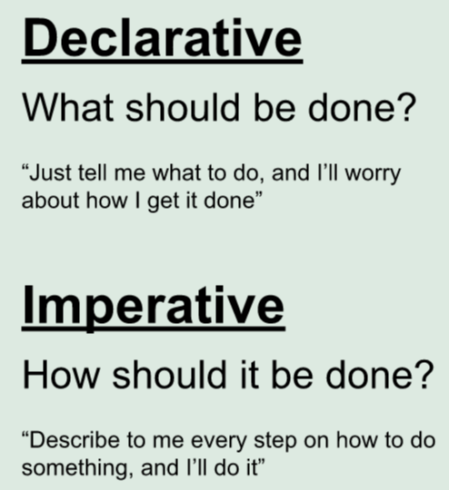

Javascript is imperative

JSX: Is a flavor of JavaScript that looks a lot like HTML

When we create an element with React we get an object as return.

/*

{

type: "h1",

key: null,

ref: null,

props: {className: "header", children: "This is JSX"},

_owner: null,

_store: {}

}

*/